**EXPERIMENT 10**

**AIM :** Demonstrate version control in Git and Github.

**ALGORITHM :**

1. Complete the registration in Github by using your email id.
2. Install git in your system.  
   to know the status of git run the command   
   git status
3. Create your github email id by using the following command  
   git config --global user.email “[you@example.com](mailto:you@example.com)”
4. Create yor user name by using  
   git config --global user.name "Your Name"
5. Create a new project in your system and initialize the folder in git, open your folder path in in CLI (cmd) and run the command  
   git init
6. After initializing create the three html files in that folder, file names are index.html, home.html and registration.html.
7. In that first add the index.html from your working directory to staging area by using the command  
   git add index.html  
   check the status run the command  
   git status
8. After that move your file to staging area to local repository by using the command  
   git commit -m "to know the changes to others"
9. Move from your local repository to remote repository, first you have to create the new repository.

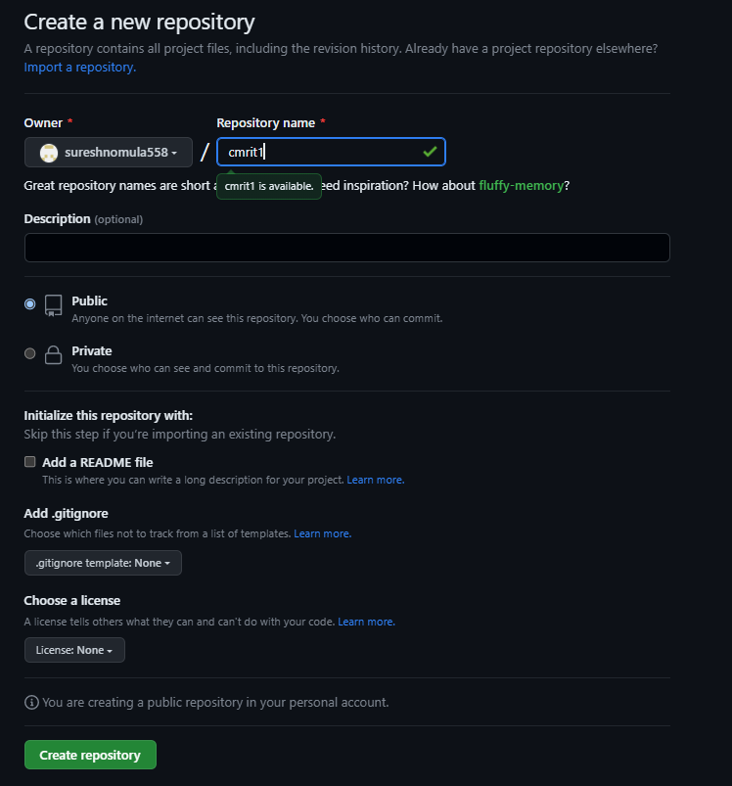

1. Select create repository you will get remote origin link. By help of this link you can establish connection between your local repository to remote repository.  
   git remote add origin <https://github.com/sureshnomula558/cmrit1.git>
2. To deploy your original code in main master that is master(master is your main branch)  
   to know your main branch run the command  
   git branch  
   for deploying your project or repository in your github run the command  
   git push -u origin master  
   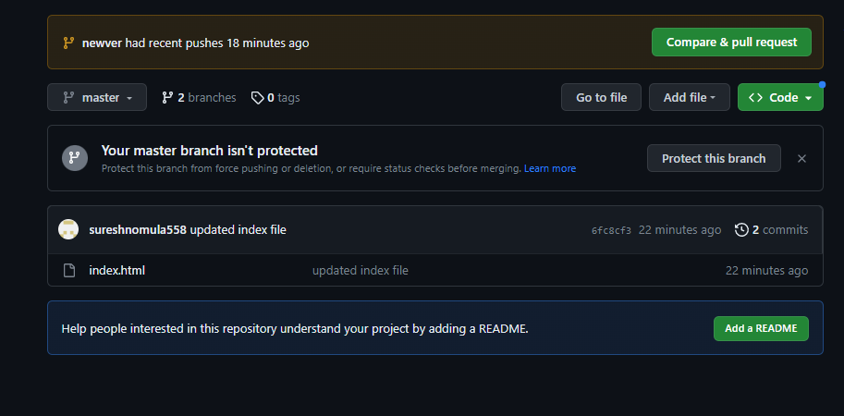

**CREATING VERSION CONTROL SYSTEM**

1. Create new branch (means copy of your project or new version) by using the command  
   git checkout -b "newver"
2. After creating the new branch add the remaining files to staging area   
   git add home.html  
   git add registration.html
3. Move files from your staging area to local repository by using  
   git commit -m "new version of project"
4. Finally you have to move your new project or version to new branch by using  
   git push --set-upstream origin newver
5. New version and new branch will be created in your github repository.

Final Output

